Python Activity Based Learning
Case Study 1: Electricity Bill Calculator
1. Problem Statement
Develop a Python program to calculate the electricity bill based on the number of
consumed by a customer.
The program should calculate energy charges using the following rates:
• 0–100 units: Rs. 2 per unit.
• 101–200 units: Rs. 3 per unit for additional units.
2. Objectives
- To understand conditional statements in Python.
- To calculate electricity charges using different rates.
- To use nested if-else and elif statements.
- To understand user input and output.
- To calculate the final bill by adding fixed charges.
3. Assumptions
- Electricity consumption is entered in units.
- Units must be a non-negative integer.
- The fixed charge is Rs. 50.
- Electricity rates are applied according to the given slabs.
- No additional taxes or charges are included.
4. Algorithm
- Start.
- Read electricity units from the user.
- Check whether units are less than zero.
- If yes, display "Invalid units".
- Otherwise, check whether units are less than or equal to 100.
- If true, calculate bill = units × 2.
- Otherwise, check whether units are less than or equal to 200.
- If true, calculate bill = 100 × 2 + (units − 100) × 3.
- Otherwise, calculate bill = 100 × 2 + 100 × 3 + (units − 200) × 5.
- Add Rs. 50 as a fixed charge.
- Display energy charge, fixed charge and total bill.
- Stop.
5. Flowchart
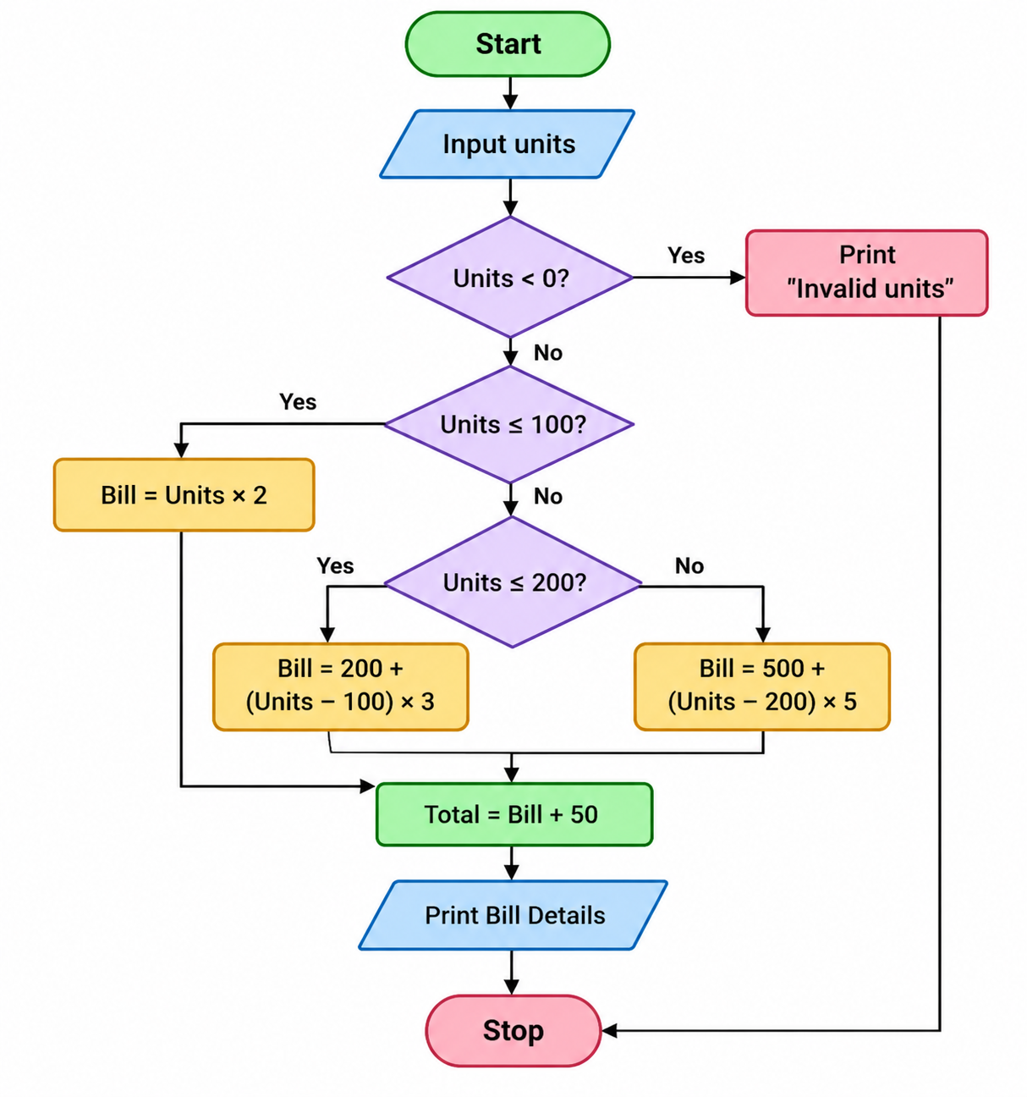
- Pseudocode
START
INPUT units
IF units < 0 THEN
PRINT "Invalid units"
ELSE
IF units <= 100 THEN
bill = units * 2
ELSE IF units <= 200 THEN
bill = 100 * 2 + (units - 100) * 3
ELSE
bill = 100 * 2 + 100 * 3 + (units - 200) * 5
END IF
total = bill + 50
PRINT energy charge
PRINT fixed charge
PRINT total bill
END IF
STOP
7. Python Source Code
units = int(input("Enter electricity units consumed: "))
if units < 0:
print("Invalid units")
else:
if units <= 100:
bill = units * 2
elif units <= 200:
bill = 100 * 2 + (units - 100) * 3
else:
bill = 100 * 2 + 100 * 3 + (units - 200) * 5
total = bill + 50
print("Energy charge: Rs.", bill)
print("Fixed charge: Rs. 50")
print("Total electricity bill: Rs.", total)
8. Outputs
Enter electricity units consumed: 250
Energy charge: Rs. 750
Fixed charge: Rs. 50
Total electricity bill: Rs. 800
9. Python Concepts Used
- Variables
- Integer data type
- Input and output statements
- If-else statements
- Nested conditional statements
- Arithmetic operators
10. Conclusion
The Electricity Bill Calculator program calculates the total electricity bill based on the units consumed. It uses conditional statements and arithmetic operations to apply different electricity rates. This program helps beginners understand decision-making statements and real-life problem-solving using Python.
Case Study 2: Product Billing System
1. Problem Statement
Develop a Python program to calculate the total bill of multiple products purchased by a customer. The program should accept product name, price and quantity. It should calculate the amount for each product and add it to the total amount. If the total amount is Rs. 1000 or more, a 10% discount should be applied. Finally, display the total amount, discount and final bill.
2. Objectives
- To understand loops in Python.
- To perform arithmetic calculations.
- To use if-else statements.
- To calculate product-wise amounts.
- To apply discounts based on the total bill.
3. Assumptions
- Number of products is entered by the user.
- Product price can be a decimal value.
- Quantity must be an integer.
- A 10% discount is given when the total is Rs. 1000 or above.
- No additional taxes are applied.
4. Algorithm
- Start.
- Read the number of products.
- Initialize total = 0.
- Repeat for each product:
  - Read product name, price and quantity.
  - Calculate amount = price × quantity.
  - Add amount to total.
  - Display product name and amount.
- Check whether total is greater than or equal to 1000.
- If yes, calculate 10% discount; otherwise, discount = 0.
- Calculate final bill = total − discount.
- Display total amount, discount and final bill.
- Stop.
5. Flowchart
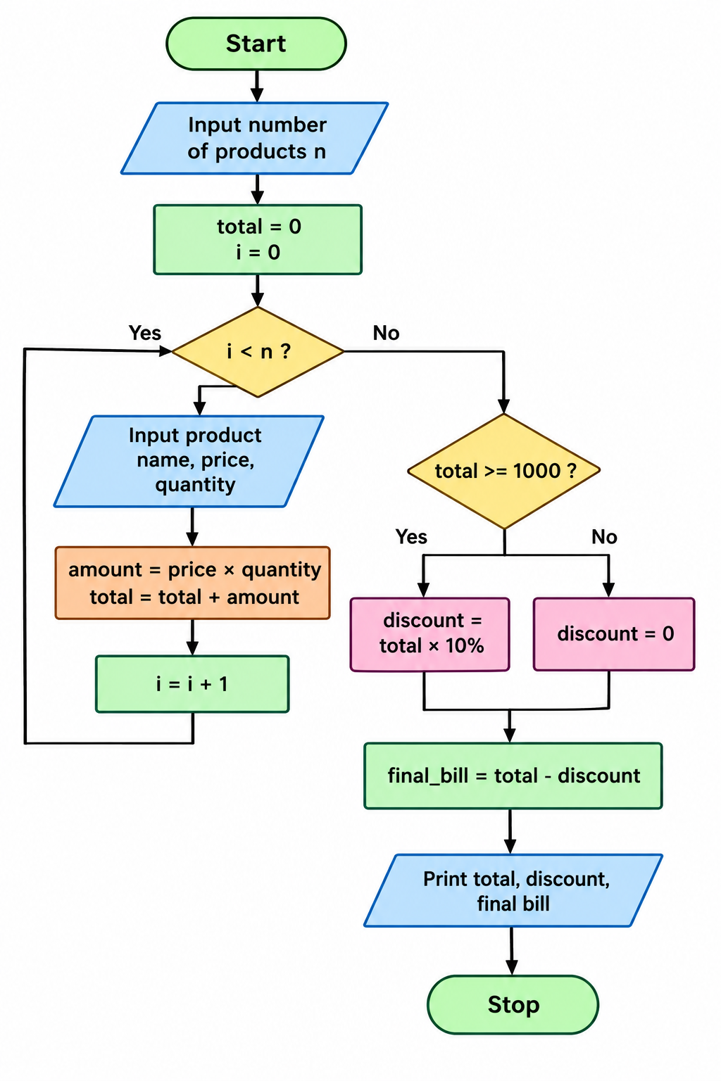
- Pseudocode
START
INPUT n
total = 0
FOR i = 1 TO n
INPUT name, price, quantity
amount = price * quantity
total = total + amount
PRINT name, amount
END FOR
IF total >= 1000 THEN
discount = total * 0.10
ELSE
discount = 0
END IF
final_bill = total - discount
PRINT total, discount, final_bill
STOP
- Python Source Code
n = int(input("Enter number of products: "))
total = 0

for i in range(n):
name = input("Enter product name: ")
price = float(input("Enter price: "))
quantity = int(input("Enter quantity: "))

amount = price * quantity
total = total + amount

print(name, "Amount: Rs.", round(amount, 2))

if total >= 1000:
discount = total * 0.10
else:
discount = 0

final_bill = total - discount

print("Total amount: Rs.", round(total, 2))
print("Discount: Rs.", round(discount, 2))
print("Final bill: Rs.", round(final_bill, 2))
8 Outputs
Enter number of products: 2
Enter product name: Pen
Enter price: 100
Enter quantity: 5
Pen Amount: Rs. 500.0

Enter product name: Book
Enter price: 150
Enter quantity: 4
Book Amount: Rs. 600.0

Total amount: Rs. 1100.0
Discount: Rs. 110.0
Final bill: Rs. 990.0
9. Python Concepts Used
- Variables
- Input and output statements
- For loop
- If-else statements
- Arithmetic operators
- Float and integer data types
- Accumulator (total = total + amount)
- Round function
10. Conclusion
The Product Billing System calculates the total cost of multiple products and applies a 10% discount when the total amount is Rs. 1000 or above. This program helps students understand loops, conditional statements and arithmetic operations in Python.
Your Case Study 2 is ready! You can use this format in your project report and GitHub repository.
Case Study 3: Student Attendance Management System
1. Problem Statement
Develop a Python program to calculate a student's attendance percentage based on the total classes held and classes attended. The program should check whether the student is eligible for the examination. If attendance is 75% or above, display "Eligible for examination". Otherwise, display "Not eligible for examination" and calculate the minimum additional classes required to reach 75% attendance.
2. Objectives
- To calculate attendance percentage.
- To understand conditional statements.
- To use arithmetic operators.
- To check examination eligibility.
- To calculate additional classes required.
3. Assumptions
- Total classes held must be greater than zero.
- Attended classes cannot be negative.
- Attended classes cannot exceed total classes held.
- Minimum attendance required is 75%.
- Additional classes attended are assumed to be attended without missing any.
4. Algorithm
- Start.
- Read total classes held and classes attended.
- Check whether attendance details are valid.
- If invalid, display "Invalid attendance details".
- Otherwise, calculate attendance percentage.
- Display attendance percentage.
- Check whether percentage is greater than or equal to 75.
- If yes, display "Eligible for examination".
- Otherwise:
  - Display "Not eligible for examination".
  - Calculate minimum additional classes required.
  - Display the required classes.
- Stop.
5. Flowchart

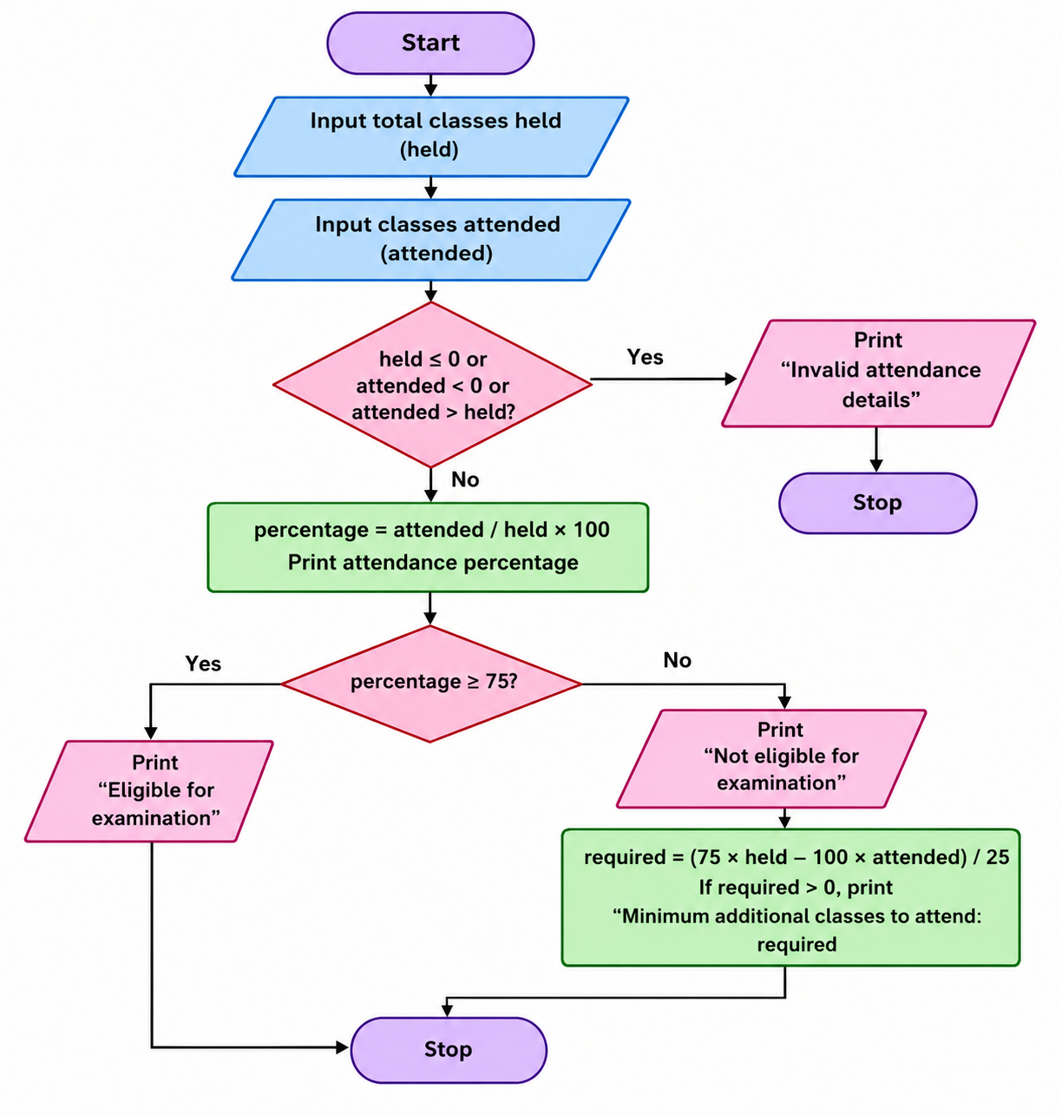
6. Pseudocode
START

INPUT held, attended

IF held <= 0 OR attended < 0 OR attended > held
PRINT "Invalid attendance details"

ELSE
percentage = attended / held * 100
PRINT percentage

IF percentage >= 75
PRINT "Eligible for examination"
ELSE
PRINT "Not eligible for examination"

required = (75 * held - 100 * attended) / 25

PRINT required
END IF
END IF

STOP
7.Python Source Code
held = int(input("Enter total classes held: "))
attended = int(input("Enter classes attended: "))

if held <= 0 or attended < 0 or attended > held:
print("Invalid attendance details")
else:
percentage = attended / held * 100

print("Attendance percentage:", round(percentage, 2), "%")

if percentage >= 75:
print("Eligible for examination")
else:
print("Not eligible for examination")

required = (75 * held - 100 * attended) / 25
if required > 0:
print("Minimum additional classes to attend:",
int(required))
8. Outputs
Enter total classes held: 40
Enter classes attended: 20

Attendance percentage: 50.0 %
Not eligible for examination
Minimum additional classes to attend: 20
9. Python Concepts Used
- Variables
- Integer data type
- Input and output statements
- If-else statements
- Nested conditional statements
- Arithmetic operators
- Comparison operators
10. Conclusion
The Student Attendance Management System calculates attendance percentage and checks examination eligibility. It also calculates the additional classes required to reach 75% attendance. This program helps students understand conditional statements and arithmetic operations in Python.
Case Study 4: ATM Banking System
1. Problem Statement
Develop a Python program to simulate a simple ATM banking system. The program should allow users to deposit money, withdraw money, check their current balance and exit the system. It should validate deposit and withdrawal amounts and display an appropriate message for insufficient balance or invalid input.
2. Objectives
- To understand while loops in Python.
- To use conditional statements.
- To perform deposit and withdrawal operations.
- To check the available account balance.
- To understand menu-driven programming.
3. Assumptions
- The opening balance must be non-negative.
- Deposit amount must be greater than zero.
- Withdrawal amount must be greater than zero.
- Withdrawal cannot exceed the available balance.
- The program continues until the user selects Exit.
4. Algorithm
- Start.
- Read the opening balance.
- Check whether the balance is negative.
- If negative, display "Invalid opening balance".
- Otherwise, display the ATM menu.
- Read the user's choice.
- If choice is 1, deposit the amount and update balance.
- If choice is 2, check the withdrawal amount and available balance, then withdraw if valid.
- If choice is 3, display the current balance.
- If choice is 4, display the thank-you message and exit.
- Otherwise, display "Invalid choice".
- Repeat the menu until the user selects Exit.
- Stop.
5. Flowchart
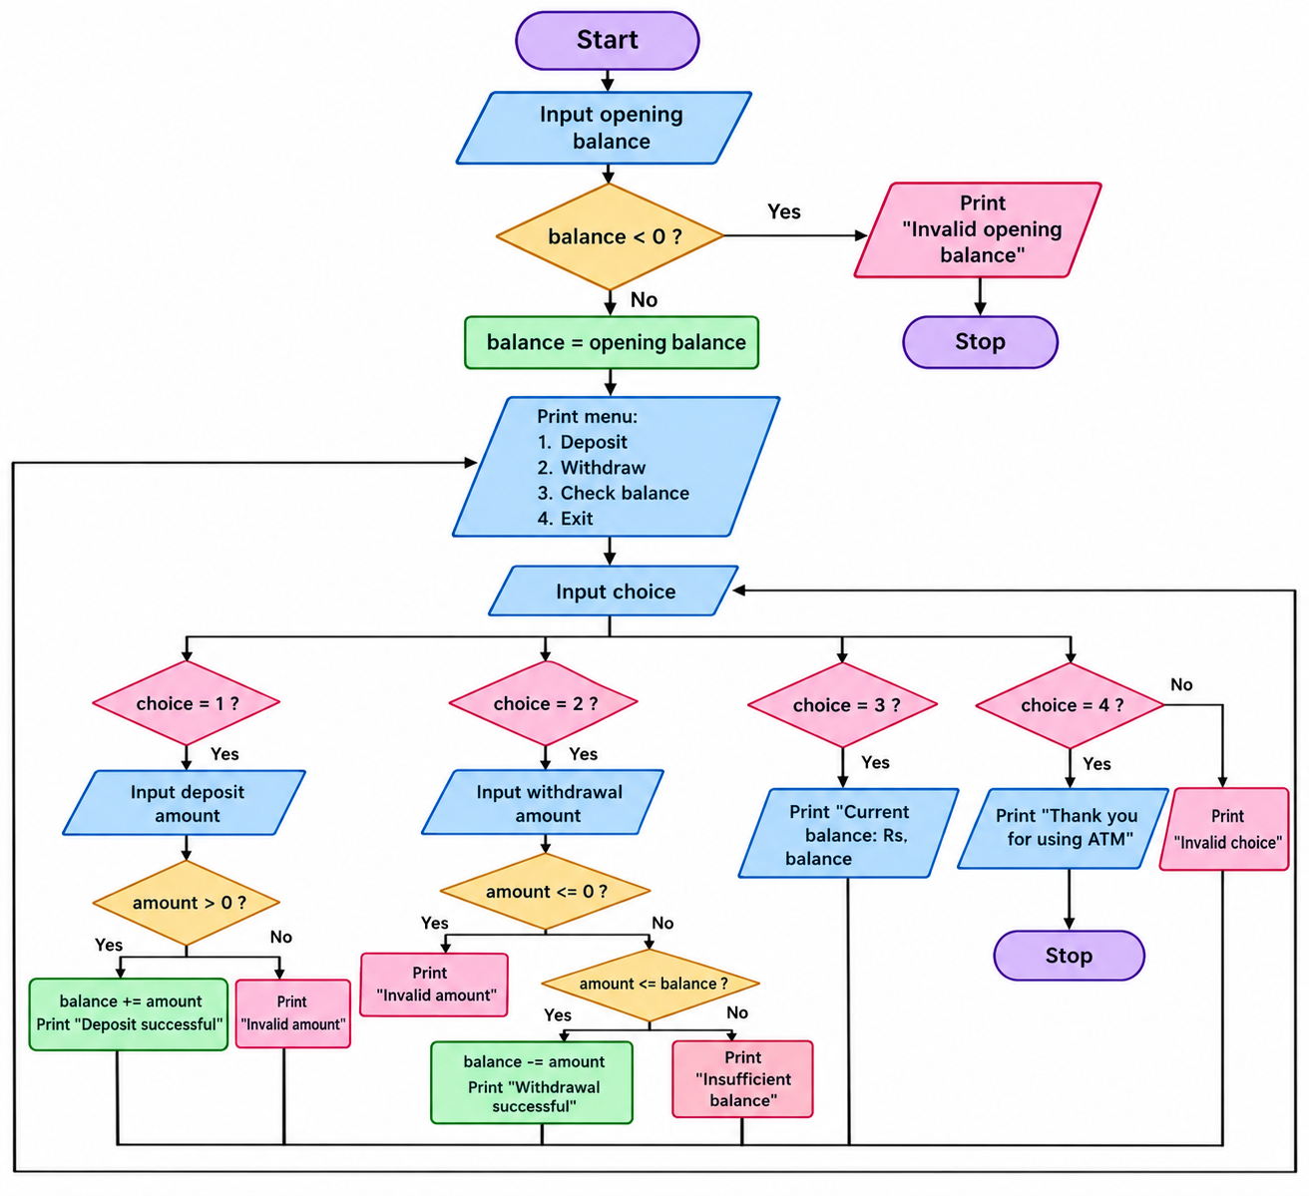
6. Pseudocode
START
INPUT balance
IF balance < 0
PRINT "Invalid opening balance"
ELSE
WHILE True
DISPLAY ATM MENU
INPUT choice
IF choice == 1
INPUT amount
IF amount > 0
balance = balance + amount
PRINT "Deposit successful"
ELSE
PRINT "Invalid amount"
ELSE IF choice == 2
INPUT amount
IF amount <= 0
PRINT "Invalid amount"
ELSE IF amount <= balance
balance = balance - amount
PRINT "Withdrawal successful"
ELSE
PRINT "nsufficient balance"
ELSE IF choice == 3
PRINT balance
ELSE IF choice == 4
PRINT "Thank you"
BREAK
ELSE
PRINT "Invalid choice"

STOP
7.Python Source Code
balance = float(input("Enter opening balance: "))

if balance < 0:
print("Invalid opening balance")
else:
while True:
print("\n1. Deposit")
print("2. Withdraw")
print("3. Check balance")
print("4. Exit")

choice = input("Enter your choice: ")

if choice == "1":
amount = float(input("Enter deposit amount: "))
if amount > 0:
balance += amount
print("Deposit successful")
else:
print("Invalid amount")

elif choice == "2":
amount = float(input("Enter withdrawal amount: "))
if amount <= 0:
print("Invalid amount")
elif amount <= balance:
balance -= amount
print("Withdrawal successful")
else:
print("Insufficient balance")

elif choice == "3":
print("Current balance: Rs.", round(balance, 2))

elif choice == "4":
print("Thank you for using ATM")
break

else:
print("Invalid choice")
8.Outputs
Enter opening balance: 1000

1. Deposit
2. Withdraw
3. Check balance
4. Exit
Enter your choice: 1
Enter deposit amount: 500
Deposit successful

1. Deposit
2. Withdraw
3. Check balance
4. Exit
Enter your choice: 3
Current balance: Rs. 1500.0

1. Deposit
2. Withdraw
3. Check balance
4. Exit
Enter your choice: 4
Thank you for using ATM
9. Python Concepts Used
- Variables
- Float data type
- Input and output statements
- While loop
- If-elif-else statements
- Break statement
- Arithmetic operators
- Comparison operators
10. Conclusion
The ATM Banking System performs deposit, withdrawal and balance-checking operations. It uses while loops and conditional statements to provide different banking services. This program helps beginners understand menu-driven programming and real-life applications of Python.
Case Study 5: Student Marks and Grade Calculator
1. Problem Statement
Develop a Python program to calculate the total marks and average marks of a student in three subjects. The program should determine whether the student has passed or failed. Based on the average marks, it should display the grade as Distinction, First Class or Pass. If marks are invalid, display an error message.
2. Objectives
- To calculate total and average marks.
- To understand for loops.
- To use if-elif-else statements.
- To find the minimum marks.
- To display the student's result.
3. Assumptions
- The student name is entered as a string.
- Marks are entered for three subjects.
- Each subject mark must be between 0 and 100.
- Minimum passing mark is 35 in each subject.
- Grades are based on average marks.
4. Algorithm
- Start.
- Read student name.
- Create an empty marks list.
- Repeat three times:
  - Read subject marks.
  - Check whether marks are between 0 and 100.
  - If invalid, display error and stop collecting marks.
  - Otherwise, add marks to the list.
- Check whether three valid marks are available.
- Calculate total and average marks.
- Display student name, total and average.
- If minimum mark is below 35, display Fail.
- Otherwise, check average:
  - 75 or above: Distinction.
  - 60 or above: First Class.
  - Otherwise: Pass.
- Stop.
5. Flowchart
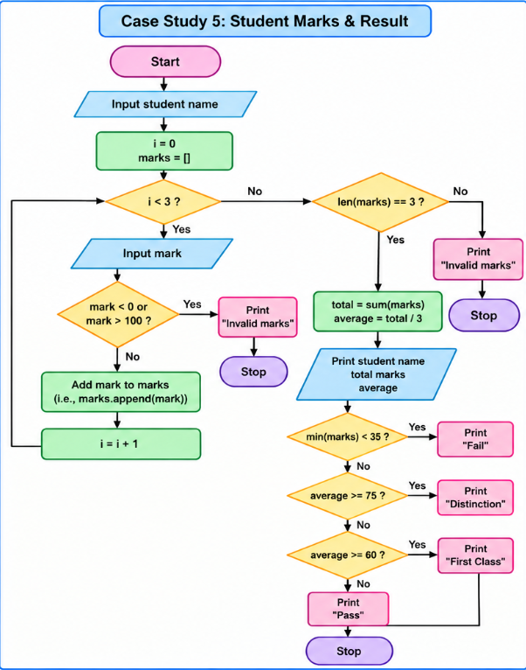
- Pseudocode
START

INPUT name
marks = []

FOR i = 1 TO 3
INPUT mark

IF mark < 0 OR mark > 100
PRINT "Invalid marks"
BREAK
ELSE
ADD mark TO marks
END IF
END FOR

IF length(marks) == 3
total = SUM(marks)
average = total / 3

PRINT name, total, average

IF minimum(marks) < 35
PRINT "Fail"
ELSE IF average >= 75
PRINT "Distinction"
ELSE IF average >= 60
PRINT "First Class"
ELSE
PRINT "Pass"
END IF
END IF

STOP
7. Python Source Code
name = input("Enter student name: ")

marks = []
for i in range(3):
mark = int(input("Enter marks: "))
if mark < 0 or mark > 100:
print("Invalid marks")
break
marks.append(mark)

if len(marks) == 3:
total = sum(marks)
average = total / 3

print("Student name:", name)
print("Total marks:", total)
print("Average:", round(average, 2))

if min(marks) < 35:
print("Result: Fail")
elif average >= 75:
print("Result: Distinction")
elif average >= 60:
print("Result: First Class")
else:
print("Result: Pass")
8.Output
Enter student name: Ravi
Enter marks: 80
Enter marks: 85
Enter marks: 90

Student name: Ravi
Total marks: 255
Average: 85.0
Result: Distinction
9.Python Concepts Used
- Variables
- Lists
- For loop
- If-elif-else statements
- Break statement
- sum() function
- min() function
- len() function
- Arithmetic operator
10.Conclusion
The Student Marks and Grade Calculator calculates total marks and average marks and determines the student's result. It helps beginners understand lists, loops, conditional statements and built-in functions in Python.
Case Study 6: Number Pattern Printing
1. Problem Statement
Develop a Python program to print a number pattern based on the number of rows entered by the user. The program should use nested for loops to display numbers in an increasing triangular pattern. If the user enters zero or a negative number, display an error message.
2. Objectives
- To understand nested for loops.
- To print number patterns.
- To use conditional statements.
- To understand loop control.
- To improve logical thinking.
3. Assumptions
- The number of rows is entered by the user.
- The number of rows must be positive.
- Each row starts printing from 1.
- Each next row contains one additional number.
4. Algorithm
- Start.
- Read the number of rows.
- Check whether the number is less than or equal to zero.
- If yes, display "Enter a positive number".
- Otherwise, repeat the outer loop from 1 to n.
- For each row, repeat the inner loop from 1 to i.
- Print the value of j with a space.
- Move to the next line after each row.
- Repeat until all rows are printed.
- Stop.
- Flowchart
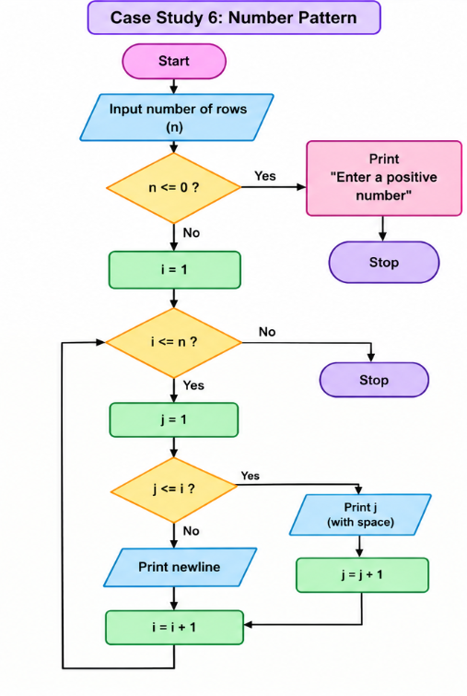
6. Pseudocode
START
INPUT n
IF n <= 0
PRINT "Enter a positive number"
ELSE
FOR i = 1 TO n
FOR j = 1 TO i
PRINT j
END FOR
PRINT NEW LINE
END FOR
END IF
STOP
7.Python Source Code
n = int(input("Enter number of rows: "))

if n <= 0:
print("Enter a positive number")
else:
for i in range(1, n + 1):
for j in range(1, i + 1):
print(j, end=" ")
print()
8. Outputs
Enter number of rows: 5

1
1 2
1 2 3
1 2 3 4
1 2 3 4 5
9. Python Concepts Used
- Variables
- Integer data type
- Input and output statements
- Nested for loops
- If-else statements
- Range function
- Print function
- Loop control
10. Conclusion
The Number Pattern Printing program prints an increasing triangular number pattern using nested for loops. It helps beginners understand loop execution and pattern-based programming in Python.
Case Study 7: Password Strength Validator
1. Problem Statement
Develop a Python program to check whether a password is valid based on certain conditions. The password must contain at least 8 characters, one uppercase letter, one lowercase letter and one digit. Display all errors if the password does not satisfy these conditions.
2. Objectives
- To validate password strength.
- To understand strings in Python.
- To use conditional statements.
- To understand lists.
- To use built-in string functions.
3. Assumptions
- Password is entered as a string.
- Minimum password length is 8 characters.
- At least one uppercase letter is required.
- At least one lowercase letter is required.
- At least one digit is required.
4. Algorithm
- Start.
- Read password.
- Create an empty errors list.
- Check whether password length is less than 8.
- Check for uppercase, lowercase and digit.
- Add error messages for every missing condition.
- Check whether the errors list is empty.
- If empty, display "Password is valid".
- Otherwise, display "Password is invalid" and print all errors.
- Stop.
5.Flowchart
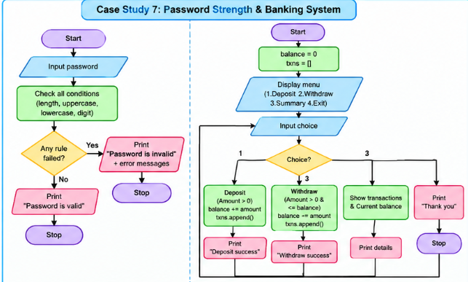
6. Pseudocode
START
INPUT password
errors = []
IF length(password) < 8
ADD "At least 8 characters required"
IF no uppercase letter
ADD "At least one uppercase letter required"
IF no lowercase letter
ADD "At least one lowercase letter required"
IF no digit
ADD "At least one digit required"
IF length(errors) == 0
PRINT "Password is valid"
ELSE
PRINT "Password is invalid"
FOR each error in errors
PRINT error
END FOR
END IF
STOP
7.Python Source Code
password = input("Enter password: ")
errors = []

if len(password) < 8:
errors.append("At least 8 characters required")
if not any(ch.isupper() for ch in password):
errors.append("At least one uppercase letter required")
if not any(ch.islower() for ch in password):
errors.append("At least one lowercase letter required")
if not any(ch.isdigit() for ch in password):
errors.append("At least one digit required")
if len(errors) == 0:
print("Password is valid")
else:
print("Password is invalid")
for error in errors:
print("-", error)
8. Outputs
Enter password: hello123
Password is invalid
- At least one uppercase letter required
9. Python Concepts Used
- Strings
- Lists
- If statements
- For loop
- len() function
- any() function
- isupper(), islower(), isdigit()
- append() method
10. Conclusion
The Password Strength Validator checks whether a password satisfies the required conditions. It helps beginners understand string functions, lists, loops and conditional statements.
Case Study 8: Bank Transaction Management System
1. Problem Statement
Develop a Python program to manage simple bank transactions. The program should allow users to deposit money, withdraw money and view their transaction summary. It should update the balance after every successful transaction and display appropriate messages for invalid amounts or insufficient balance.
2. Objectives
- To understand menu-driven programming.
- To perform deposit and withdrawal operations.
- To maintain transaction records.
- To use lists and tuples.
- To understand while loops.
3. Assumptions
- Initial balance is Rs. 0.
- Deposit amount must be greater than zero.
- Withdrawal amount must be greater than zero.
- Withdrawal cannot exceed the current balance.
- The program continues until the user selects Exit.
4. Algorithm
- Start.
- Initialize balance = 0 and an empty transactions list.
- Display the transaction menu.
- Read the user's choice.
- If choice is 1, read deposit amount.
- If amount is positive, update balance and store transaction.
- If choice is 2, read withdrawal amount.
- Check amount and available balance.
- If valid, subtract amount and store transaction.
- If choice is 3, display all transactions and current balance.
- If choice is 4, display thank-you message and exit.
- Otherwise, display invalid option.
- Repeat the menu until Exit.
- Stop.
5.Flowchart
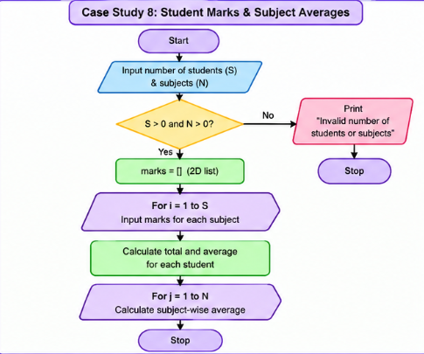

6. Pseudocode
START
balance = 0
transactions = []
WHILE True
DISPLAY menu
INPUT choice
IF choice == 1
INPUT amount
IF amount > 0
balance = balance + amount
ADD deposit to transactions
PRINT "Deposit successful"
ELSE
PRINT "Invalid amount"
ELSE IF choice == 2
INPUT amount
IF amount <= 0
PRINT "Invalid amount"
ELSE IF amount <= balance
balance = balance - amount
ADD withdrawal to transactions
PRINT "Withdrawal successful"
ELSE
PRINT "Insufficient balance"

ELSE IF choice == 3
DISPLAY transactions
DISPLAY balance
ELSE IF choice == 4
PRINT "Thank you"
BREAK
ELSE
PRINT "Invalid option"
END WHILE
STOP
7. Python Source Code
balance = 0.0
transactions = []

while True:
print("\n1. Deposit")
print("2. Withdraw")
print("3. Transaction Summary")
print("4. Exit")

choice = input("Choose option: ")

if choice == "1":
amount = float(input("Enter deposit: "))
if amount > 0:
balance += amount
transactions.append(("Deposit", amount))
print("Deposit successful")
else:
print("Invalid amount")

elif choice == "2":
amount = float(input("Enter withdrawal: "))
if amount <= 0:
print("Invalid amount")
elif amount <= balance:
balance -= amount
transactions.append(("Withdrawal", amount))
print("Withdrawal successful")
else:
print("Insufficient balance")

elif choice == "3":
for transaction, amount in transactions:
print(transaction, "Rs.", amount)
print("Current balance: Rs.", round(balance, 2))

elif choice == "4":
print("Thank you")
break

else:
print("Invalid option")
8.Outputs
1. Deposit
2. Withdraw
3. Transaction Summary
4. Exit

Choose option: 1
Enter deposit: 1000
Deposit successful

Choose option: 2
Enter withdrawal: 300
Withdrawal successful

Choose option: 3
Deposit Rs. 1000.0
Withdrawal Rs. 300.0
Current balance: Rs. 700.0

Choose option: 4
Thank you
9. Python Concepts Used
- Variables
- Lists
- Tuples
- While loop
- If-elif-else statements
- Break statement
- Append method
- Arithmetic operators
10. Conclusion
The Bank Transaction Management System performs deposits, withdrawals and transaction summaries. It helps students understand loops, lists, tuples and conditional statements.
Case Study 9: Student Marks Analysis System
1. Problem Statement
Develop a Python program to collect marks of multiple students in multiple subjects. Calculate each student's total and average marks. Also calculate the average marks of each subject. Display all the results using nested loops and lists.
2. Objectives
- To understand nested loops.
- To use two-dimensional lists.
- To calculate student totals and averages.
- To calculate subject averages.
- To improve data-handling skills.
3. Assumptions
- Number of students must be positive.
- Number of subjects must be positive.
- Marks are entered as integers.
- Marks are assumed to be between 0 and 100.
- Each student has marks in all subjects.
4. Algorithm
- Start.
- Read number of students and subjects.
- Check whether both values are positive.
- If invalid, display an error message.
- Otherwise, create an empty marks list.
- Use an outer loop to collect marks for each student.
- Use an inner loop to collect marks for each subject.
- Store all marks in a two-dimensional list.
- Calculate and display each student's total and average.
- Calculate and display each subject's average.
- Stop.
5.Flowchart
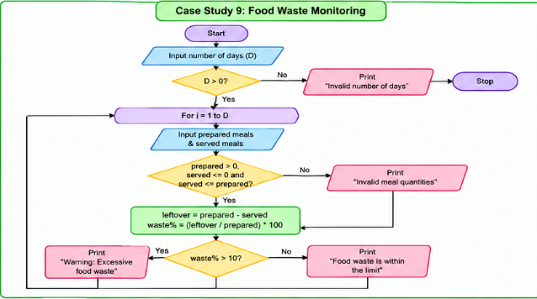
6. Pseudocode
START

INPUT students, subjects

IF students <= 0 OR subjects <= 0
PRINT "Invalid number of students or subjects"

ELSE
marks = []

FOR i = 1 TO students
row = []

FOR j = 1 TO subjects
INPUT mark
ADD mark TO row
END FOR

ADD row TO marks
END FOR

FOR each student
total = SUM(student marks)
average = total / subjects
PRINT total, average
END FOR

FOR each subject
CALCULATE subject average
PRINT subject average
END FOR
END IF

STOP
7.Python Source Code
students = int(input("Enter number of students: "))
subjects = int(input("Enter number of subjects: "))

if students <= 0 or subjects <= 0:
print("Invalid number of students or subjects")
else:
marks = []

for i in range(students):
row = []
print("Enter marks for student", i + 1)

for j in range(subjects):
mark = int(input("Enter mark: "))
row.append(mark)

marks.append(row)

for i in range(students):
total = sum(marks[i])
average = total / subjects

print("Student", i + 1, "marks:", marks[i])
print("Total:", total)
print("Average:", round(average, 2))

for j in range(subjects):
subject_total = 0

for i in range(students):
subject_total += marks[i][j]

print("Subject", j + 1,
"average:", round(subject_total / students, 2))
8. Outputs
Enter number of students: 2
Enter number of subjects: 2

Enter marks for student 1
Enter mark: 80
Enter mark: 90

Enter marks for student 2
Enter mark: 70
Enter mark: 60

Student 1 marks: [80, 90]
Total: 170
Average: 85.0

Student 2 marks: [70, 60]
Total: 130
Average: 65.0

Subject 1 average: 75.0
Subject 2 average: 75.0
9. Python Concepts Used
- Variables
- Lists
- Nested lists
- Nested for loops
- If-else statements
- sum() function
- Arithmetic operators
10. Conclusion
The Student Marks Analysis System calculates individual student totals and averages, along with subject-wise averages. It helps beginners understand two-dimensional lists and nested loops.
Case Study 10: Food Waste Monitoring System
1. Problem Statement
Develop a Python program to monitor food waste for a given number of days. The program should accept the number of meals prepared and served each day. It should calculate leftover meals and food waste percentage. If food waste exceeds 10%, display a warning message.
2. Objectives
- To calculate leftover food.
- To calculate food waste percentage.
- To understand for loops.
- To use conditional statements.
- To identify excessive food waste.
3. Assumptions
- Number of days must be positive.
- Meals prepared must be greater than zero.
- Meals served cannot be negative.
- Meals served cannot exceed meals prepared.
- Food waste above 10% is considered excessive.
4. Algorithm
- Start.
- Read the number of days.
- Check whether days are positive.
- If invalid, display "Invalid number of days".
- Otherwise, repeat for each day:
  - Read meals prepared.
  - Read meals served.
  - Validate meal quantities.
  - If invalid, display error and continue to next day.
  - Calculate leftover = prepared − served.
  - Calculate waste percentage.
  - Display leftover meals and waste percentage.
  - If waste percentage is greater than 10%, display warning.
  - Otherwise, display food waste within limit.
- Stop.
5.Flowchart
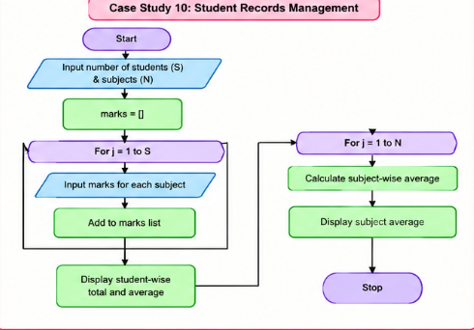n = int(input("Enter number of rows: "))

if n <= 0:
print("Enter a positive number")
else:
for i in range(1, n + 1):
for j in range(1, i + 1):
print(j, end=" ")
print()
6. Pseudocode
START

INPUT days

IF days <= 0
PRINT "Invalid number of days"

ELSE
FOR i = 1 TO days
INPUT prepared, served

IF prepared <= 0 OR served < 0 OR served > prepared
PRINT "Invalid meal quantities"
CONTINUE
END IF

leftover = prepared - served
waste_percent = (leftover / prepared) * 100

PRINT leftover, waste_percent

IF waste_percent > 10
PRINT "Warning: Excessive food waste"
ELSE
PRINT "Food waste is within the limit"
END IF
END FOR
END IF
STOP
- Python Source Code
days = int(input("Enter number of days: "))

if days <= 0:
print("Invalid number of days")
else:
for i in range(1, days + 1):
prepared = float(input("Enter meals prepared: "))
served = float(input("Enter meals served: "))

if prepared <= 0 or served < 0 or served > prepared:
print("Invalid meal quantities")
continue

leftover = prepared - served
waste_percent = leftover / prepared * 100

print("Day", i)
print("Leftover meals:", leftover)
print("Waste percentage:", round(waste_percent, 2), "%")

if waste_percent > 10:
print("Warning: Excessive food waste")
else:
print("Food waste is within the limit")
8. Outputs
Enter number of days: 2

Enter meals prepared: 100
Enter meals served: 80

Day 1
Leftover meals: 20.0
Waste percentage: 20.0 %
Warning: Excessive food waste

Enter meals prepared: 100
Enter meals served: 95

Day 2
Leftover meals: 5.0
Waste percentage: 5.0 %
Food waste is within the limit
9. Python Concepts Used
- Variables
- Float data type
- For loop
- If-else statements
- Continue statement
- Arithmetic operators
- Input and output statements
10. Conclusion
The Food Waste Monitoring System calculates leftover meals and food waste percentage. It displays warnings when food waste exceeds 10%. This program helps students understand loops, conditional statements and real-life problem-solving.

